**EFFICIENT DOCTOR PATIENT PORTAL**

**Name of the Team :** INCOGNITO

**Team Members and Roles :** Sri Chaitanya Eega -Team Leader

Srikanth Reddy Palamoor -Organizer

Ritesh Dodla -Innovator

Rahul Reddy Rondla -Peacemaker

Akhil Sai Reddy Ravula -Bureaucrat

**Project Name :** EFFICIENT DOCTOR PATIENT PORTAL

**Type of Software :** Web Application

**Platform :** Windows 10

**Aim :** Doctor Patient Portal for Southern University Student and Faculty

**Age Range :** 18 and above

**Features :** Following are the features

* **Doctor login/Register:** The system is under supervision of doctors who manages the bookings made.
* **User login/Register:** Users must first register themselves to login into the system.
* **Appointment Scheduling:** Users can view the appointment for their required date and time.
  + Book Appointment
  + Update Appointment
  + Delete Appointment
* **Search Doctor:** System allows to search doctors through categories and name.

**Delimitations :** Following are the delimitations

* Maximum 10 appointments per day
* No emergency appointments
* Only for Southern University
* General Practice, ENT, Orthopedic

In use-case diagrams, the use cases and actors define what the system does and how the actors interact with it, but not how the system works internally.



Patient Doctor

Figure 1: Use case diagram of Efficient Doctor Patient Portal

**Class Diagram**

Use-case diagrams are used in UML to represent a system's behavior and to record the system's needs.

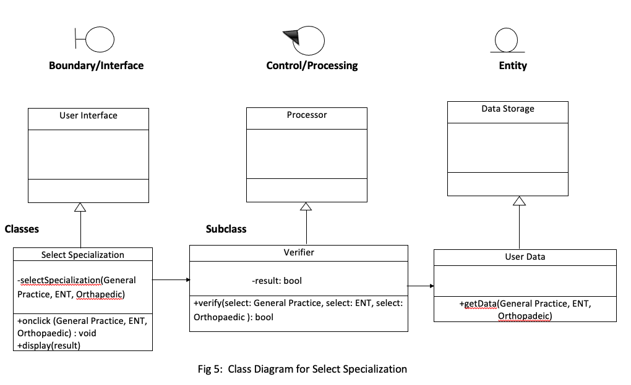

**RAPID & TESTING**

**PROTOTYPE**

* In order to login to the web portal Patient or Doctor must select the options that is mentioned

PATIENT LOGIN

DOCTOR LOGIN

* After selecting Patient or Doctor you can see the below screen where you need to enter the Email Id and Password if you are an existing user.

SUBR Doctor Patient Appointment Booking Login/Registration Page

Email Id *

Register

Login

Password*

Forgot Password

* If you are not an existing user or doctor not registered, then screen shows Invalid Email Id/Password
* If you try to login without entering any details is shows the same i.e., Invalid Email Id/Password

Invalid Email Id/Password

Forgot Password

Login

Register

Email Id *

Password*

SUBR Doctor Patient Appointment Booking Login/Registration Page

* To register user must enter First name, Last name, Email Id and Password should be entered

SUBR Doctor Patient Appointment Booking Login/Registration Page

First Name*

Last Name*

E-Mail Id *

Password *

Register

* Text

  Description automatically generatedIf user didn’t enter details or did not enter valid email id and try to register, then it pops up saying ‘Enter Required Fields’.

Register

SUBR Doctor Patient Appointment Booking Login/Registration Page

*Enter Required Fields

First Name*

Last Name*

E-Mail Id *

Password *

Enter

Confirm Password

Enter New Password

Email Id

* After logging in patient can view the dashboard as shown below and having options to choose the specialization, along with home and logout options

**Logout**

**SELECT SPECIALIZATION**

Orthopedic

General Practice

ENT

BOOK APPOINTMENT

UPDATE APPIONTMENT

DATE

MONTH

SELECT TIME

SELECT DOCTOR

Describe your problem…

YEAR

**BOOK APPOINTMENT**

**Logout**

**BOOK APPOINTMENT**

DATE

MONTH

SELECT TIME

SELECT DOCTOR

Describe your problem…

BOOK APPOINTMENT

UPDATE APPOINTMENT

**Logout**

2021

2022

2023

**BOOK APPOINTMENT**

DATE

SELECT TIME

SELECT DOCTOR

Describe your problem…

YEAR

BOOK APPOINTMENT

UPDATE APPOINTMENT

**Logout**

JANUARY

FEBURARY

MARCH

APRIL

MAY

JUNE

JULY

AUGUST

SEPTUMBER

OCTOBER

NOVEMBER

DECEMBER

**BOOK APPOINTMENT**

MONTH

SELECT TIME

SELECT DOCTOR

Describe your problem…

YEAR

BOOK APPOINTMENT

UPDATE APPOINTMENT

**Logout**

01

02

03

04

05

06

07

08

09

10

11

12

13

14

15

16

17

18

19

20

21

22

23

24

25

26

27

28

29

30

31

**BOOK APPOINTMENT**

DATE

MONTH

SELECT DOCTOR

Describe your problem…

YEAR

BOOK APPOINTMENT

UPDATE APPOINTMENT

**Logout**

11:00 AM

11:30 AM

12:00 PM

12:30 PM

01:00 PM

01:30 PM

02:30 PM

DR. AKHIL REDDY

DR. SIRI METTU

DR. DADLA

DR. JAMES

DR. SMITH

**BOOK APPOINTMENT**

DATE

MONTH

SELECT TIME

Describe your problem…

YEAR

BOOK APPOINTMENT

UPDATE APPOINTMENT

**Logout**

**Logout**

APPOINTMENT NUMBER

SELECT DOCTOR

SELECT TIME

DATE

MONTH

YEAR

**UPDATE APPOINTMENT**

Describe your problem…

UPDATE APPOINTMENT

DELETE APPOINTMENT

**Logout**

DD/MM/YYYY

VIEW APPOINTMENTS

**Logout**

15/04/2021

VIEW APPOINTMENTS

**Logout**

PATIENT NAME: Johnson

DATE: 15/04/2021

TIME: 12:00 PM

SELECTED SPECIALIST: ENT

SELECTED DOCTOR: DR. AKHIL REDDY

DECRIPTION: ……

**Team Leader (Sri Chaitanya Eega)**

Managed the team dynamics throughout the project. I ensure the focus of the team on project deliverable. Responsible for setting the expectations for the team. Responsible to set the direction for their team during project work. Contributing to overall project objectives. Completing individual deliverables. Providing expertise. Working with users to establish and meet business needs. Documenting the process. Updated the documents and meeting details along with the suggested few changes to class diagram.

**Innovator (Ritesh Dodla)**

We oversee healthcare projects from start to finish, monitoring and reporting on the progress throughout the process. I also supervise and direct all team members involved in the project. Gave ideas in developing security algorithms to protect medical records and other sensitive information in the hospital setting. Proposed the project is aimed to develop to maintain the day-to-day state of admission/discharge of patients, list of doctors, reports generation. Worked on sequence diagram designing.

**Bureaucrat (Akhil Sai Reddy Ravula)**

In this project, my role as a Bureaucrat I have helped in selecting the project (Efficient Doctor Patient Portal), and we have conducted team meetings in which we discussed the project. I have helped with the documentation and I have prepared the rapid prototype with the help of Rahul Rondla(Peacemaker) and Ritesh Dodla(Innovator), in which we have given the skeleton view of what our project is going to be. Worked with Rahul reddy in designing class diagram and also considered the team members views in designing it.

**Organizer (Srikanth Reddy Palamoor)**

I am one of the team members who proposed this project (Efficient Doctor Patient Portal) that helps the southern university students and faculty to easily access into portal page and book an appointment. I made the changes in the document as discussed in the class and came up with the platform that is windows 10. Gone through software languages like java, python, C sharp that suits project. I organized zoom meetings made sure everyone attends meetings and noted down everyone’s points. Updated the documents and meeting details along with the suggested few changes to class diagram

**Peacemaker (Rahul Reddy Rondla)**

I came up with this project and title I made sure everyone is okay with project and title. I suggested project features like login page for patients and doctors, appointment booking page, medical history and described the features. I helped in preparing the rapid prototype and updated according to the changes made in the document. Gone through all the basic requirements for the project and helped my team members to get the job completed. Worked with Akhil sai reddy on class diagram designing and verification and considered all team members views in designing

**SEQUENCE DIAGRAM**

The sequence diagram is a useful tool for documenting a system's needs and fleshing out its architecture.

**TEAM MEETING DETAILS**

**Team Name: INCOGNITO**

**Project Name:** Efficient Doctor Patient Portal

First Meeting on 06/09/21

Time Duration:5PM-6PM

Meeting purpose: Project selection

**Topics Discussed:**

* Discussed about few webs’ application projects like food delivery application, attendance sheet application, Efficient Doctor Patient Portal.
* Finalised on Efficient Doctor Patient Portal.

Meeting participants:

Team Leader: Sri Chaitanya Eega

Organiser: Srikanth Palamoor

Innovator: Ritesh Dodla

Peacemaker: Rahul Rondla

Bureaucrat: Akhil Sai Reddy Ravula

🡺Srikanth and Rahul proposed this project (Efficient Doctor Patient Portal) that helps the southern university students and faculty to easily access into portal page and book an appointment.

Type of meeting: In person

Second Meeting on 06/13/21

Time Duration:5PM-6PM

Team Name: INCOGNITO

Meeting purpose: Discussion about changes made in project document.

**Topics Discussed:**

* Changes made in the document.
* Discussed on Project features and added description regarding them.
* Regarding delimitations and features.
* Added details in the features and delimitations.

Meeting participants:

Team Leader: Sri Chaitanya Eega

Organiser: Srikanth Palamoor

Innovator: Ritesh Dodla

Peacemaker: Rahul Rondla

Bureaucrat: Akhil Sai Reddy Ravula

🡺Chaitanya made the changes in the document as discussed in the class and came up with the platform that is windows 10.

🡺Ritesh suggested project features like login page for patients and doctors, appointment booking page, medical history and described the features.

Type of meeting: Zoom.

Third Meeting on 06/15/21

Time duration:5pm – 6pm

Meeting purpose: Finalised project software & platform.

Topics Discussed:

* Gone through some related software languages that suits project application.
* Finalized type of platform that is windows 10.

Meeting Participants:

Team Leader: Sri Chaitanya Eega

Organiser: Srikanth Palamoor

Innovator: Ritesh Dodla

Peacemaker: Rahul Rondla

Bureaucrat: Akhil Sai Reddy Ravula

🡺Akhil helped in preparing the rapid prototype and updated according to the changes made in the document.

🡺Gone through software languages like java, python, C sharp that suits project.

Forth Meeting on 06/24/21

Time duration: 5pm-6pm

Type of Meeting: Zoom

Meeting purpose: Requirements Workflow

Topics discussed:

* Worked on Appointment Management system.
* Discussed on Use case Diagram.
* Developed a Use Case Diagram.
* Discussed on login page- How to design login page.

Meeting Participants:

Team Leader: Sri Chaitanya Eega

Organiser: Srikanth Palamoor

Innovator: Ritesh Dodla

Peacemaker: Rahul Rondla

Bureaucrat: Akhil Sai Reddy Ravula

🡺Chaitanya made changes in the Use Case Diagram.

🡺Akhil did the Login page.

Fifth Meeting on 06/28/21

Time duration: 5pm-6pm

Type of Meeting: Zoom

Meeting purpose: Discussed Use Case Diagram

Topics discussed:

* Doctor/Patient portal page, both doctor and patient portal should be in one portal page or different and decided to put in one page for both doctor and patient.
* Appointment Booking page, there are limited appointments for the day.
* Discussed on patient medical history, weather history should be saved or not.
* Finalised on both patient and doctor has to login through same portal, medical history is going to saved secured and appointments per day are limited.

Meeting Participants:

Team Leader: Sri Chaitanya Eega

Organiser: Srikanth Palamoor

Innovator: Ritesh Dodla

Peacemaker: Rahul Rondla

Bureaucrat: Akhil Sai Reddy Ravula

🡺Rahul & Ritesh worked on Patient Portal page and Appointment booking page.

Sixth Meeting on 07/04/21

Time duration: 5pm-6pm

Type of Meeting: Zoom

Meeting purpose: Changes made in Use Case Diagram

Topics discussed:

* As per discussed in the class changes made in use case diagram.
* Discussed about features and made changes in Use Case.

Meeting Participants:

Team Leader: Sri Chaitanya Eega

Organiser: Srikanth Palamoor

Innovator: Ritesh Dodla

Peacemaker: Rahul Rondla

Bureaucrat: Akhil Sai Reddy Ravula

🡺Palamoor organised the use case diagram.

Seventh Meeting on 07/08/21

Time duration: 5pm-6pm

Type of Meeting: Zoom

Meeting purpose: Worked on Class Diagram

Topics discussed:

* Built Class Diagram according to Use Case Diagram.
* Discussed weather to put login sequence diagram private or public.
* Changes made public to private in Class Diagram.

Meeting Participants:

Team Leader: Sri Chaitanya Eega

Organiser: Srikanth Palamoor

Innovator: Ritesh Dodla

Peacemaker: Rahul Rondla

Bureaucrat: Akhil Sai Reddy Ravula

🡺Rahul & Akhil prepared Class Diagram.

🡺Ritesh prepared Sequence Diagram.

Eighth Meeting on 07/12/21

Time duration: 5pm-6pm

Type of Meeting: Zoom

Meeting purpose: Changes made in Class Diagram.

Topics discussed:

* In login Page changes made in classes and subclass.
* Discussed on register page weather to put it private or public.
* Added forgot password page to class diagram.

Meeting Participants:

Team Leader: Sri Chaitanya Eega

Organiser: Srikanth Palamoor

Innovator: Ritesh Dodla

Peacemaker: Rahul Rondla

Bureaucrat: Akhil Sai Reddy Ravula

🡺Chaitanya & Palamoor made changes in the class diagram and sequence diagram according as discussed in the class and added forgot password page.

Ninth Meeting on 07/15/21

Time duration: 5pm-6pm

Type of Meeting: Zoom

Meeting purpose: Updated class diagram & Sequence Diagram.

Topics discussed:

* Class diagram Update appointment & View appointment.
* Discussed Sequence diagram and finalised how it present it.
* Added User interface and User Data.

Meeting Participants:

Team Leader: Sri Chaitanya Eega

Organiser: Srikanth Palamoor

Innovator: Ritesh Dodla

Peacemaker: Rahul Rondla

Bureaucrat: Akhil Sai Reddy Ravula

🡺All team members shared their point of view on Classes and Subclasses weather to put it private or public.